Alexander Baldree
08/18/26
Module 2.2 Assignment
CSD440

GitHub Link:
https://github.com/Panda-Alex21687/CSD440

XAMPP Installed/ Running:
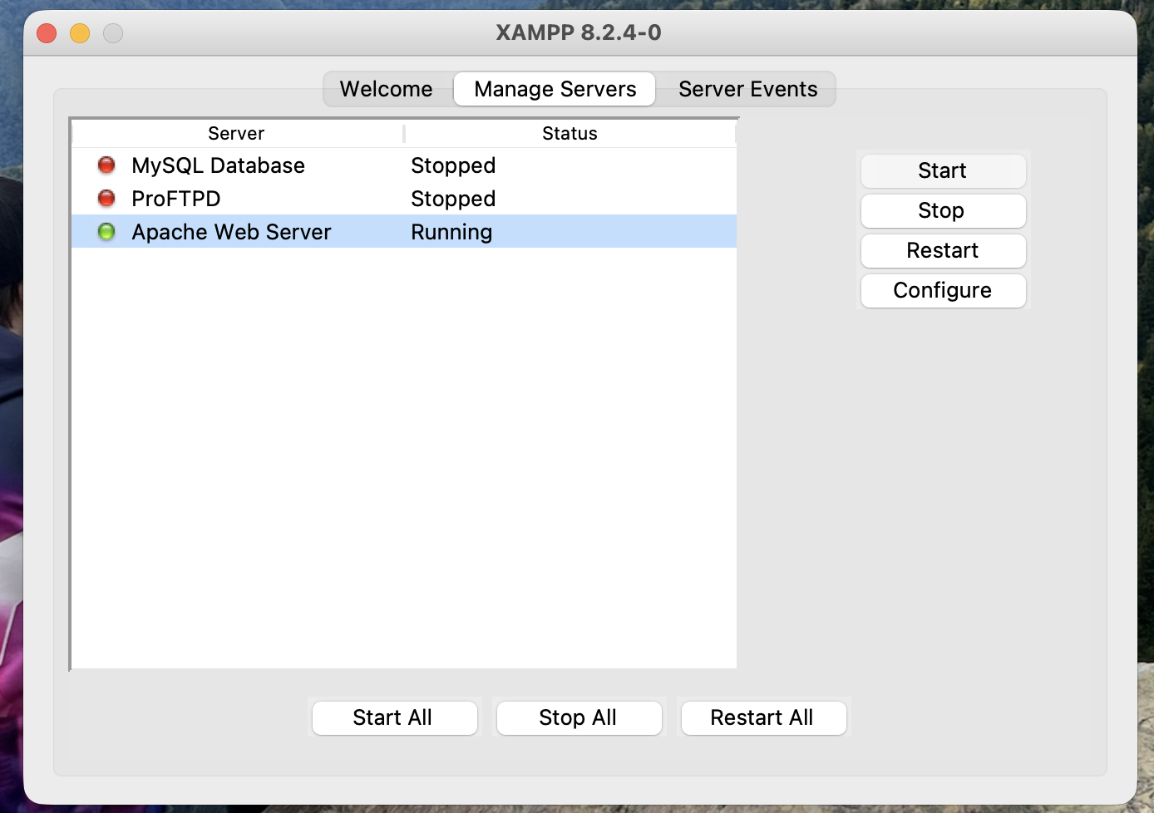

AlexTable2.php:
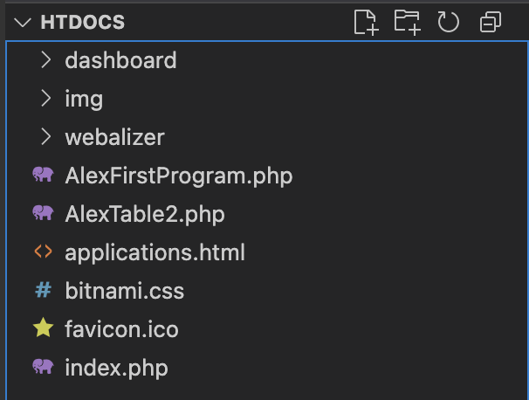
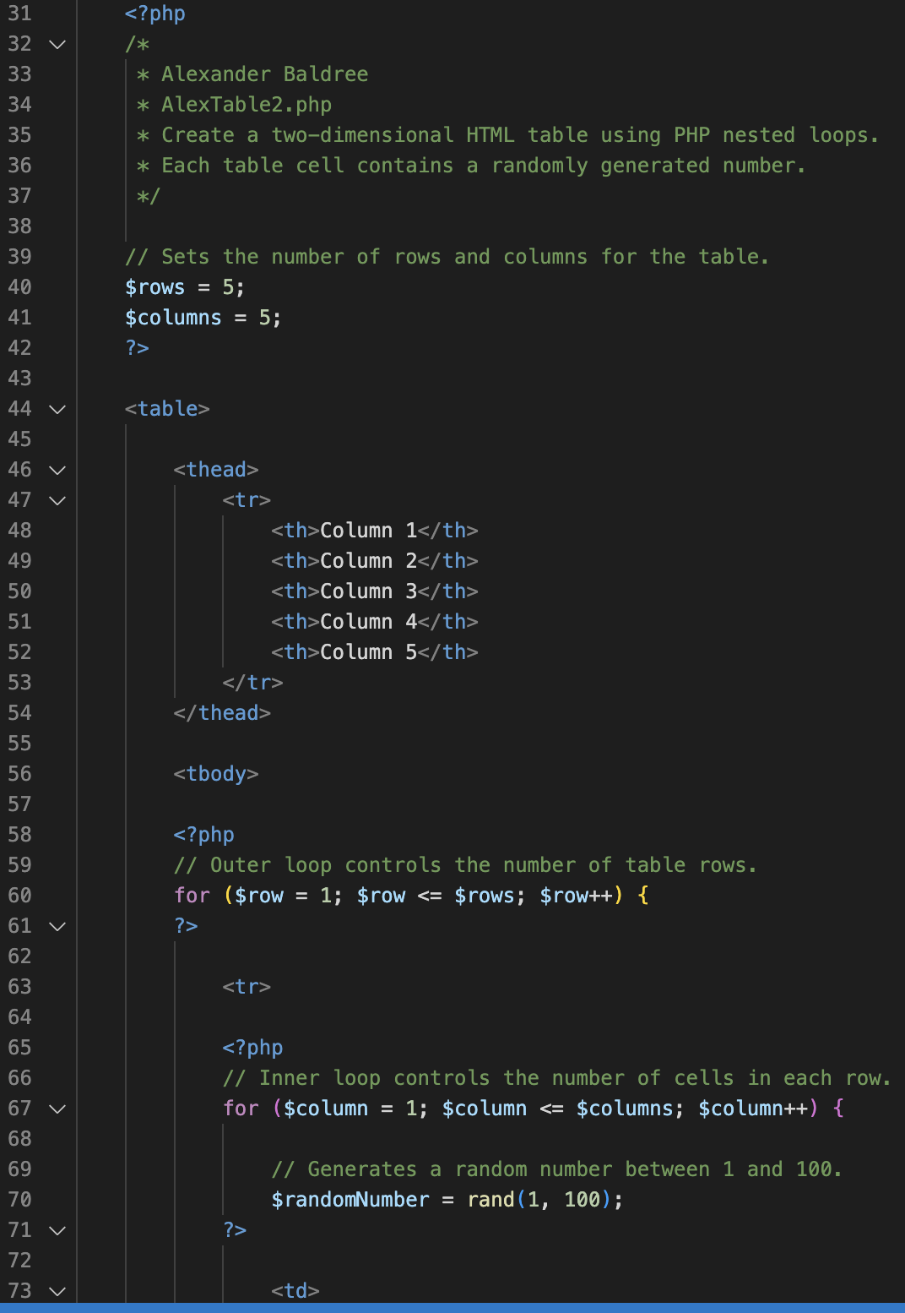
AlexTable2.php loaded in xampp random numbers when refreshed:

